SCHOOL OF COMPUTER APPLICATIONS

NoSQL Project
Product Inventory Management System Using MongoDB
Submitted to: | Submitted by:
Mr. Harendra Singh | Student's name: Aprajita Dwivedi
Department: BCA 22(DS & AI)  Date: 25th September | Roll no: 34  University roll no: 1250258119

1. CREATE DATABASE
MongoDB Query:
use Store
Explanation: Creates or switches to the Store database.
Output Screenshot:
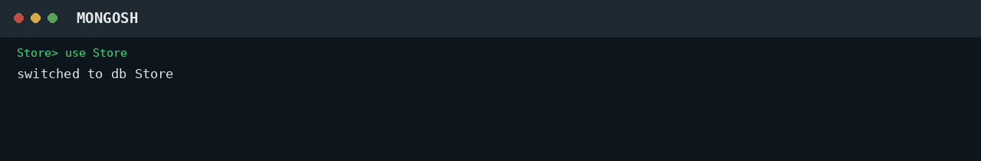

2. CREATE COLLECTION
MongoDB Query:
db.createCollection("products")
Explanation: Creates a collection named products.
Output Screenshot:
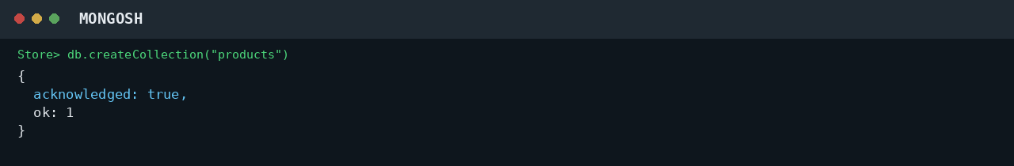

3. INSERT 50 PRODUCTS
MongoDB Query:
db.products.insertMany([
{productId:1, name:"AeroBook 14", stock:15, price:62000, category:"Laptop"},
{productId:2, name:"AeroBook 15", stock:57, price:52000, category:"Laptop"},
{productId:3, name:"TabPro 11", stock:25, price:48500, category:"Tablet"},
{productId:4, name:"SnapPro D5", stock:20, price:48000, category:"Camera"},
{productId:5, name:"NovaBook Air", stock:18, price:78000, category:"Laptop"},
{productId:6, name:"NovaBook Pro", stock:58, price:43000, category:"Laptop"},
{productId:7, name:"Pixelon 9", stock:40, price:31000, category:"Mobile"},
{productId:8, name:"ViewMax 43", stock:23, price:66500, category:"Television"},
{productId:9, name:"SnapPro D7", stock:41, price:75500, category:"Camera"},
{productId:10, name:"Pixelon 9 Pro", stock:20, price:48000, category:"Mobile"},
{productId:11, name:"MirrorX Z6", stock:20, price:45000, category:"Camera"},
{productId:12, name:"MirrorX Z8", stock:41, price:76500, category:"Camera"},
{productId:13, name:"ActionCam 4K", stock:26, price:92000, category:"Camera"},
{productId:14, name:"Galaxo M14", stock:30, price:36000, category:"Mobile"},
{productId:15, name:"Galaxo S22", stock:48, price:68500, category:"Mobile"},
{productId:16, name:"Nordic One", stock:5, price:53500, category:"Mobile"},
{productId:17, name:"ActionCam Hero", stock:6, price:68000, category:"Camera"},
{productId:18, name:"StudioBook 16", stock:12, price:93000, category:"Laptop"},
{productId:19, name:"ViewMax 50", stock:16, price:48000, category:"Television"},
{productId:20, name:"ViewMax 55", stock:26, price:91000, category:"Television"},
{productId:21, name:"ClearVision 32", stock:38, price:60500, category:"Television"},
{productId:22, name:"Nordic Two", stock:16, price:57000, category:"Mobile"},
{productId:23, name:"PocketCam 20", stock:26, price:94000, category:"Camera"},
{productId:24, name:"ClearVision 65", stock:25, price:43500, category:"Television"},
{productId:25, name:"OLED Ultra 55", stock:20, price:88000, category:"Television"},
{productId:26, name:"UltraBook S13", stock:10, price:71500, category:"Laptop"},
{productId:27, name:"TabPro 12", stock:35, price:40000, category:"Tablet"},
{productId:28, name:"GamerBook X", stock:55, price:52500, category:"Laptop"},
{productId:29, name:"ProBook 450", stock:22, price:90000, category:"Laptop"},
{productId:30, name:"EliteBook Z", stock:40, price:66500, category:"Laptop"},
{productId:31, name:"OLED Ultra 65", stock:18, price:50000, category:"Television"},
{productId:32, name:"SlimBook 13", stock:17, price:40500, category:"Laptop"},
{productId:33, name:"PocketCam 30", stock:14, price:86000, category:"Camera"},
{productId:34, name:"TabLite 8", stock:10, price:48500, category:"Tablet"},
{productId:35, name:"SmartTV Neo 40", stock:50, price:72000, category:"Television"},
{productId:36, name:"Vivid 5G", stock:50, price:29000, category:"Mobile"},
{productId:37, name:"CoreBook 17", stock:34, price:74500, category:"Laptop"},
{productId:38, name:"TabLite 10", stock:51, price:70500, category:"Tablet"},
{productId:39, name:"StudioCam R5", stock:9, price:42000, category:"Camera"},
{productId:40, name:"StudioCam R7", stock:59, price:81500, category:"Camera"},
{productId:41, name:"SmartTV Neo 50", stock:53, price:49500, category:"Television"},
{productId:42, name:"FlexBook 2in1", stock:53, price:57000, category:"Laptop"},
{productId:43, name:"VlogCam ZV", stock:60, price:41500, category:"Camera"},
{productId:44, name:"Vivid Neo", stock:11, price:73000, category:"Mobile"},
{productId:45, name:"PadAir 10", stock:45, price:25000, category:"Tablet"},
{productId:46, name:"PadAir Max", stock:35, price:41000, category:"Tablet"},
{productId:47, name:"CineWall 75", stock:56, price:70500, category:"Television"},
{productId:48, name:"Orbit A55", stock:11, price:53000, category:"Mobile"},
{productId:49, name:"Orbit X", stock:34, price:76500, category:"Mobile"},
{productId:50, name:"TravelCam 100", stock:55, price:71500, category:"Camera"}
])
Explanation: Inserts multiple product documents into the collection.
Output Screenshot:
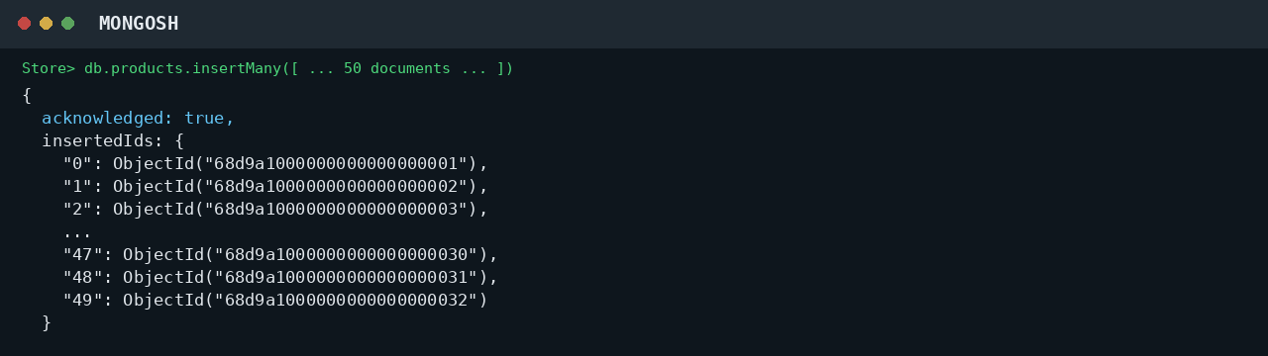

4. DISPLAY ALL PRODUCTS
MongoDB Query:
db.products.find()
Explanation: Retrieves all documents from the products collection.
Output Screenshot:
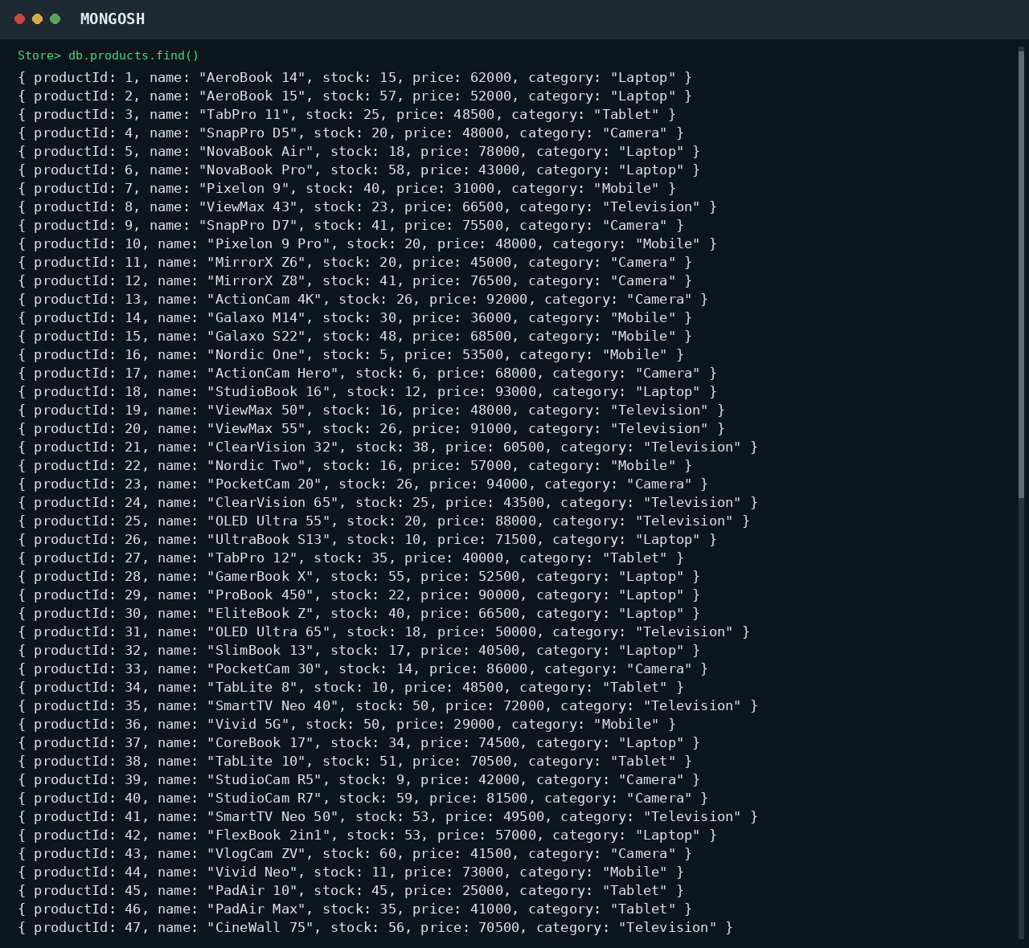

5. EQUAL TO — $eq
MongoDB Query:
db.products.find({price: {$eq: 62000}})
Explanation: Finds products whose price is exactly 62000.
Output Screenshot:
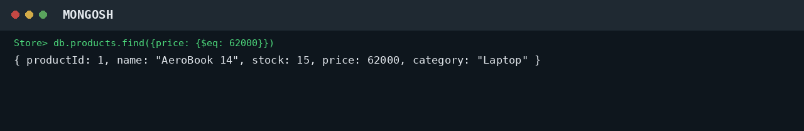

6. GREATER THAN — $gt
MongoDB Query:
db.products.find({price: {$gt: 85000}})
Explanation: Finds products whose price is greater than 85000.
Output Screenshot:
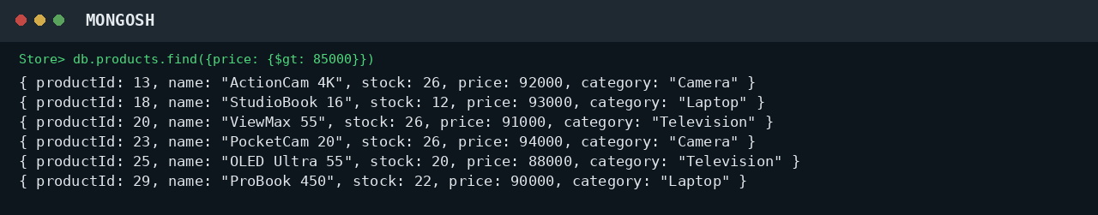

7. LESS THAN — $lt
MongoDB Query:
db.products.find({price: {$lt: 35000}})
Explanation: Finds products whose price is less than 35000.
Output Screenshot:
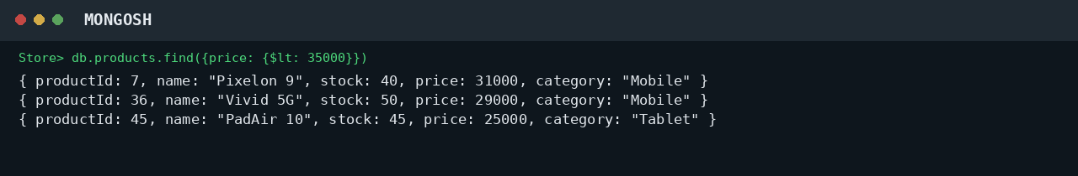

8. GREATER THAN OR EQUAL TO — $gte
MongoDB Query:
db.products.find({price: {$gte: 90000}})
Explanation: Finds products whose price is 90000 or above.
Output Screenshot:
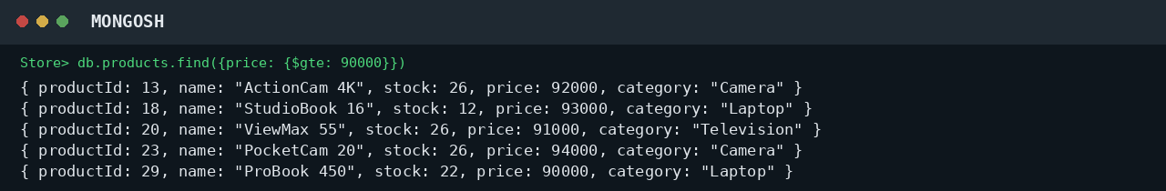

9. LESS THAN OR EQUAL TO — $lte
MongoDB Query:
db.products.find({price: {$lte: 40000}})
Explanation: Finds products whose price is 40000 or below.
Output Screenshot:
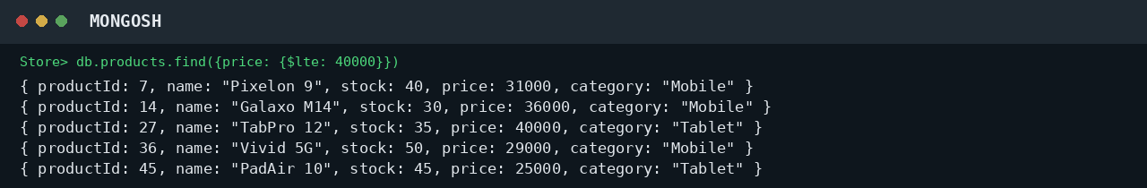

10. UPDATE OPERATION
MongoDB Query:
db.products.updateOne(
{productId:5},
{$set:{price:95000}}
)
Explanation: Updates the price to 95000 of the product with productId 5.
Output Screenshot:
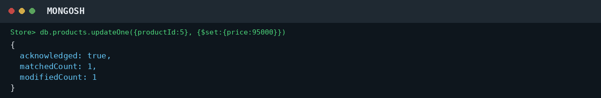

11. DELETE ONE OPERATION
MongoDB Query:
db.products.deleteOne({productId:10})
Explanation: Deletes one document matching productId 10.
Output Screenshot:
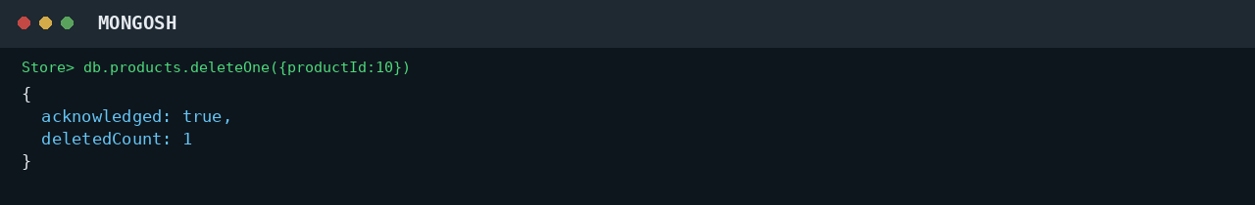

12. DELETE MANY OPERATION
MongoDB Query:
db.products.deleteMany({
price: {$lt:35000}
})
Explanation: Deletes all products having a price below 35000.
Output Screenshot:
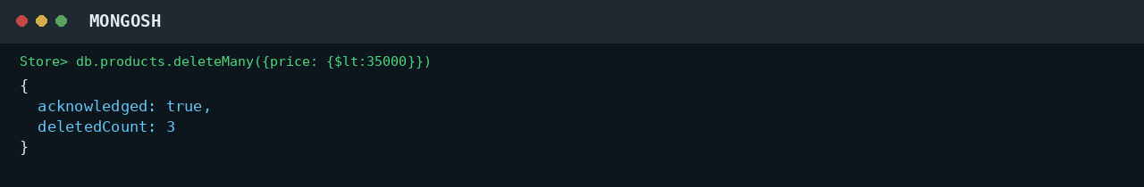

13. AND OPERATION — $and
MongoDB Query:
db.products.find({
$and:[
{price:{$gt:80000}},
{stock:26}
]
})
Explanation: Finds products satisfying both conditions.
Output Screenshot:
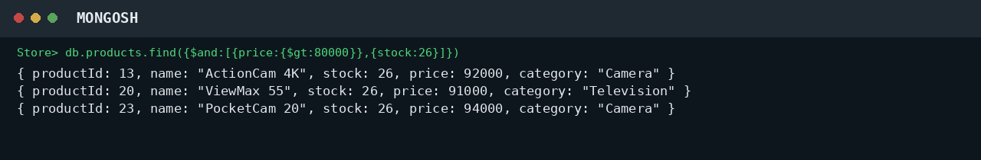

14. OR OPERATION — $or
MongoDB Query:
db.products.find({
$or:[
{category:"Laptop"},
{category:"Mobile"}
]
})
Explanation: Finds products that belong to the Laptop or Mobile category.
Output Screenshot:
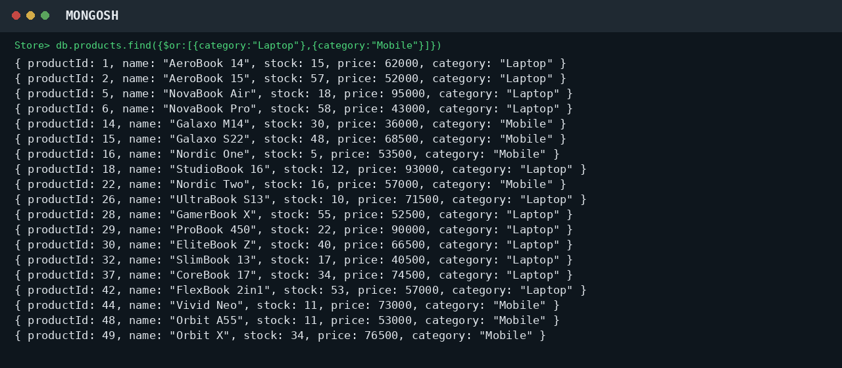

15. SORT OPERATION
A. MongoDB Query:
db.products.find().sort({price: 1})
Explanation: Sorts products by price from lowest to highest. Use 1 for ascending order.
Output Screenshot:
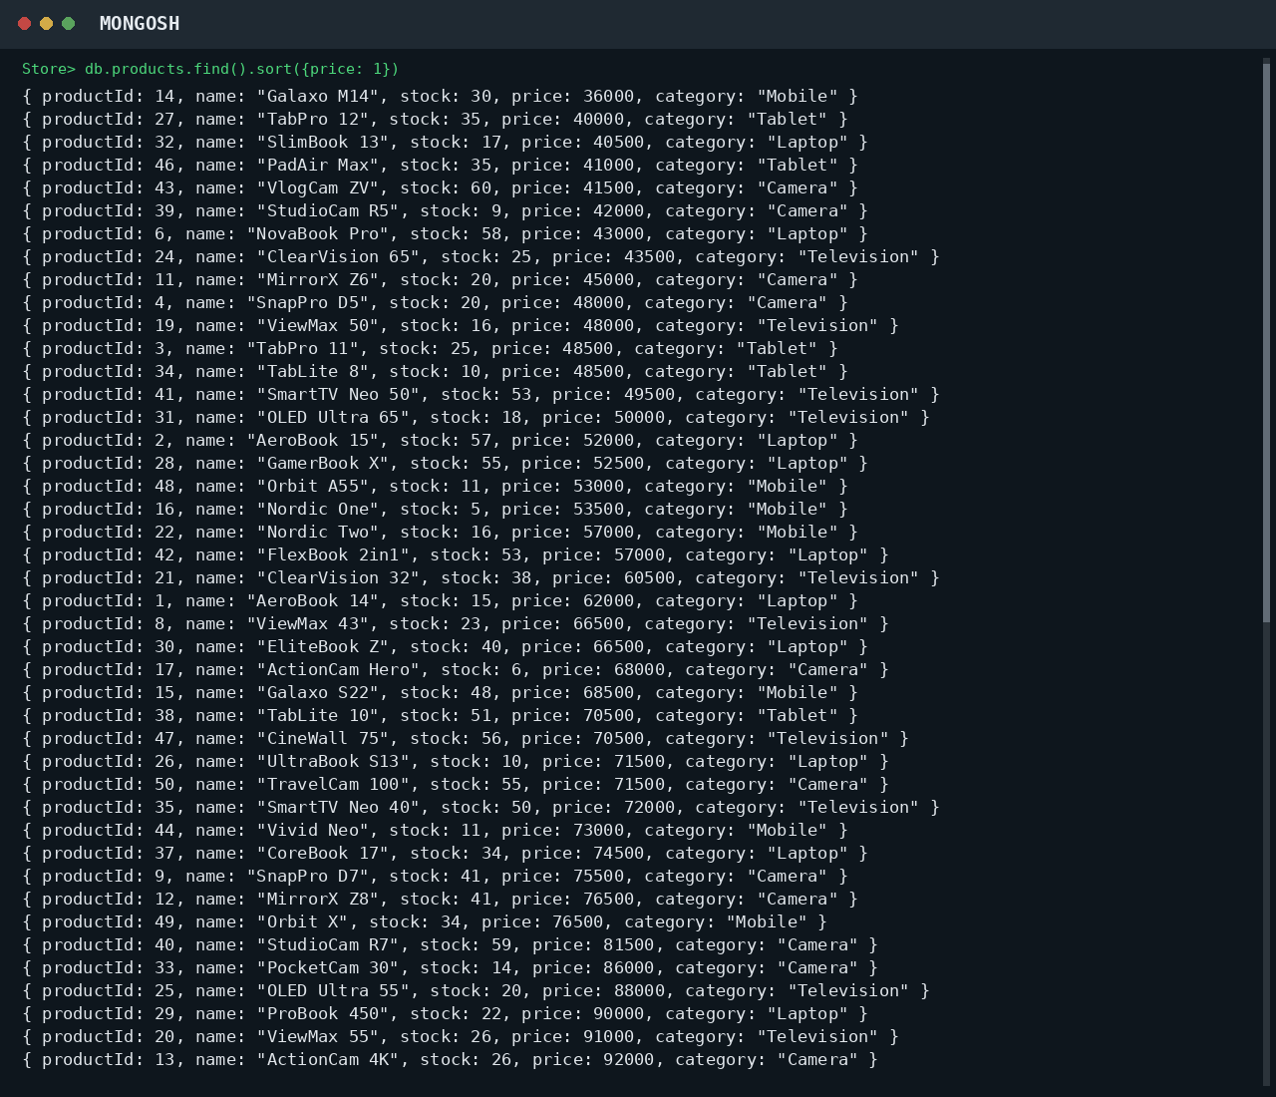
B. MongoDB Query:
db.products.find().sort({price: -1})
Explanation: Sorts products by price from highest to lowest. Use -1 for descending order.
Output Screenshot:
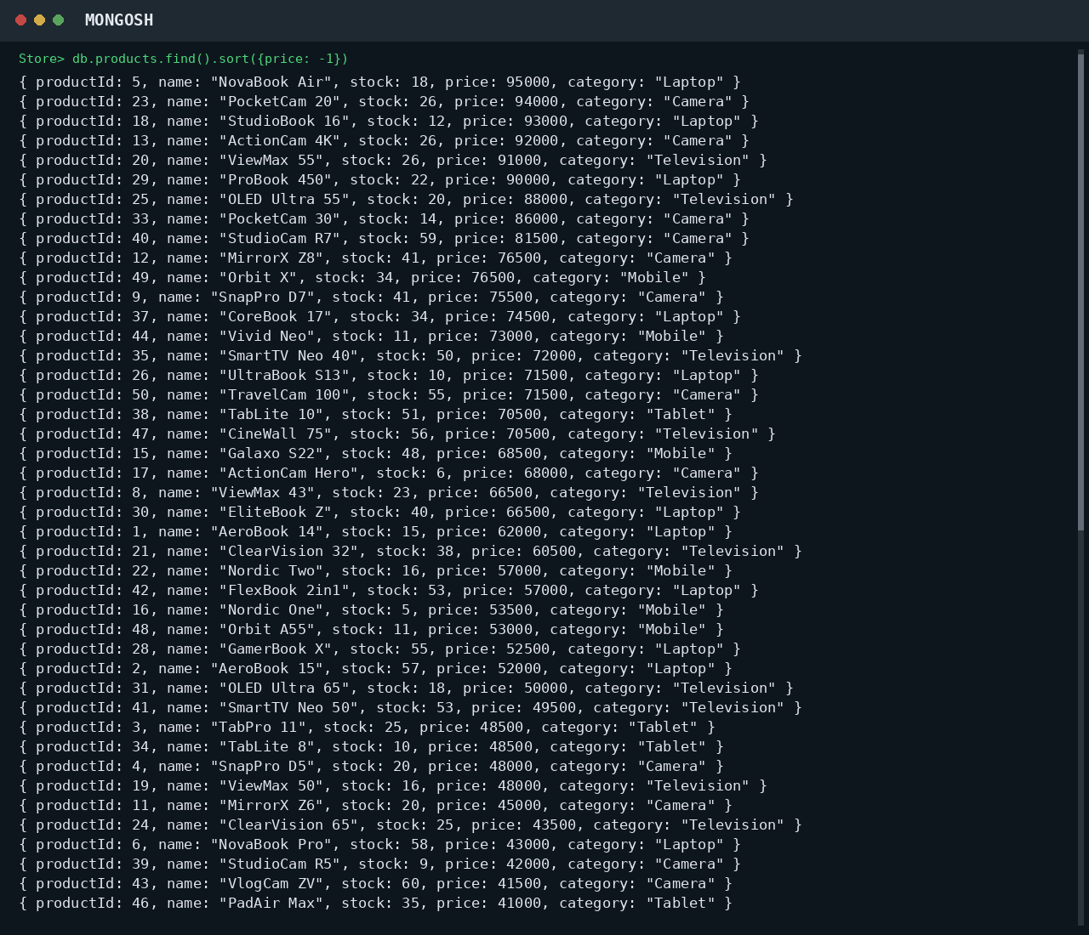

16. LIMIT OPERATION
MongoDB Query:
db.products.find().limit(5)
Explanation: Displays only the first five documents.
Output Screenshot:
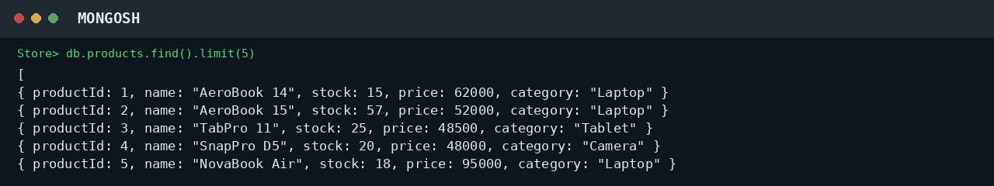

17. SEARCH BY CATEGORY
MongoDB Query:
db.products.find({category:"Laptop"})
Explanation: Finds all products that belong to the Laptop category.
Output Screenshot:
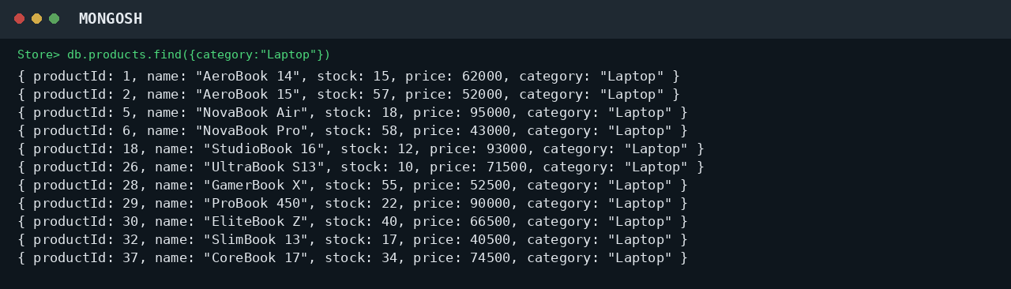

18. COUNT DOCUMENTS
MongoDB Query:
db.products.countDocuments()
Explanation: Counts documents currently present in the collection (performed after the delete operations).
Output Screenshot:
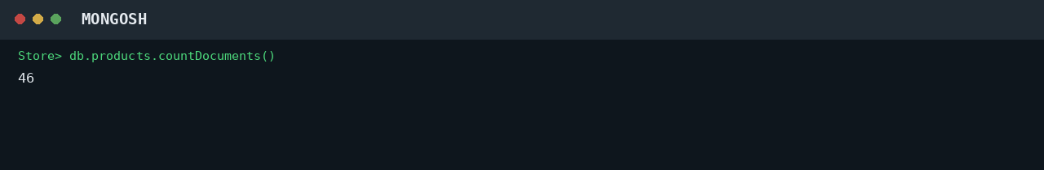

MONGODB OPERATORS USED
Operator | Meaning | Example
$eq | Equal to | price: {$eq:62000}
$gt | Greater than | price: {$gt:85000}
$lt | Less than | price: {$lt:35000}
$gte | Greater than or equal to | price: {$gte:90000}
$lte | Less than or equal to | price: {$lte:40000}
$and | All conditions true | $and:[...]
$or | At least one condition true | $or:[...]

CONCLUSION
This project provided practical knowledge of NoSQL databases using MongoDB. A Product Inventory Management System containing product information was created and different MongoDB operations were performed on the data.
Through this project, I learned how to insert, retrieve, update, and delete documents. I also learned how to arrange data in ascending and descending order, how comparison operators such as $eq, $gt, $lt, $gte, and $lte work, along with logical operators such as $and and $or.
Overall, this project helped me understand how MongoDB can be used to manage and query product data efficiently.

